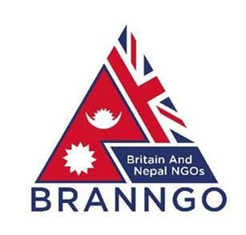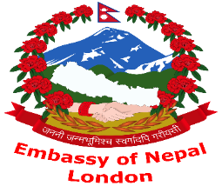
BRANNGO CONFERENCE 18TH JULY 2019
By Nick Hinton
BRANNGO held its fourth conference (since its inception in May 2018) on 18th July 2019. By kind permission of His Excellency the Nepalese Ambassador to the UK, Dr Durga Bahadur Subedi, it was hosted in the Nepalese Embassy in London. The simultaneous Nepali Tea Festival being held there ensured conference delegates remained refreshed throughout the proceedings!
His Excellency gave a warm welcome to those attending and the presenters. David Thomas, the Chairman of BRANNGO, reminded the audience of the organisation’s aims and explained that as membership increased it would facilitate greater collaboration between NGOs working in Nepal. To this end BRANNGO was developing use of a database (‘INTERBRANNGO’) to identify those with similar interests and help bring them together. At the same time, communication was being improved through enhancements to the website and a quarterly newsletter. Later in the proceedings David Morrell, one of the BRANNGO Committee members, led an interactive session promoting use of the BRANNGO Facebook page. The BRANNGO Committee was also working to build communities of interest around the UN Sustainable Development Goals, which would provide a useful and productive framework aligning NGOs working in Nepal with high-level Nepalese Government goals in this regard as well as providing a focus for inter-NGO discussions and coordination in line with the BRANNGO charter.
Marcus Jones MP then gave a short talk on aspects of the Britain-Nepal relationship. His interest in Nepal is prompted by the existence of a large Nepalese community in his constituency in Nuneaton. He spoke about the 2 countries’ shared history and mutual interest in trade and tourism, highlighting hydro-electric power and Nepal’s aspiration to become a centre for financial services as 2 particular areas of interest. He sees UK’s role in this as helping Nepal to achieve stability and prosperity through a broad range of activities and collaboration.
Mr Andrew Sparkes, former UK Ambassador to Nepal and Chairman of the Britain-Nepal Society, then spoke about what the British Embassy in Kathmandu can do to help NGOs working in the country, highlighting the website (https://www.gov.uk/world/organisations/british-embassy-kathmandu) as a useful first source of information. He gave advice on how to apply for UK Government funding, highlighting that you need a ‘special selling point’ if you want DFID funds. He mentioned that the Embassy has a small project fund but stressed the word ‘small’. He also said that NGOs are a useful source of information for the Embassy and he welcomed them keeping in touch. Organisations such as the National Federation of NGOs (NGN), The Association of INGOs (AIN) and BRANNGO are also very helpful in promoting links with other organisations and the Embassy.
Dr Gillian Holdsworth, the Co-Chair of the UK Board of Trustees, gave a very interesting briefing on the Britain Nepal Medical Trust (BNMT). The Trust was founded in 1967 and had the treatment of tuberculosis as its main aim, but this extended into proactive preventative programmes including communications and training and it is now active in a number of other medical areas. A key element of the Trust’s success and longevity has been its emphasis on sustainability and its structure, with its executive arm well-established in Nepal but funding and governance driven out of the UK.
Mr Kul Acharaya, the Vice President for the UK of the Non-Resident Nepali Association (NRNA), gave a presentation on his organisation, which was established in 2003 to unite and bind the Nepali diaspora worldwide. He pointed to the very comprehensive website (https://nrna.org/) and emphasised that NRNA is keen to collaborate with BRANNGO and its members in any way that might bring benefit to both organisations.
Mr Sharad Raj Aran, Deputy Chief of Mission at the Embassy, then gave an interesting presentation on Nepali tea. After lunch – and tea – Mr Rajendra Kumar Khetan, the Chairman of the Nepal-Britain Chamber of Commerce, spoke about the role his organisation has in fostering collaboration between the 2 countries.
Christopher Lavender then spoke in some detail about his experiences working for the Kadoorie Charitable Aid Foundation. He explained that the Kadoorie Agricultural Aid Association (KAAA) had a community focus, as the name implies, providing training, advice and assistance. The Charitable Aid Foundation funds projects. Some 670 have been carried out worldwide of which approximately 200 have been in Nepal. He identified that many INGOs are inefficient, and that at the end of the day ‘it’s a people business’. Due diligence and field visits are therefore essential to ensure success. He gave some useful pointers on how to complete a proposal form successfully, highlighting the need for credibility. Major Yambahadur Gurung then gave some examples of some Foundation projects in Nepal.
After David Morrall’s ‘hands on’ session encouraging the audience to log on and use the BRANNGO Facebook pages, His Excellency the Nepalese Ambassador then made his closing remarks. As well as thanking the presenters he gave an overview of the current situation in Nepal. He pointed out that the country is making a complicated transition to a peaceful, secure and stable democracy. There have been many improvements since 2015, and the multi-party system is essentially executing a liberal agenda. He mentioned that 2020 is a ‘Visit Nepal’ year, and encouraged everyone to try and do so!

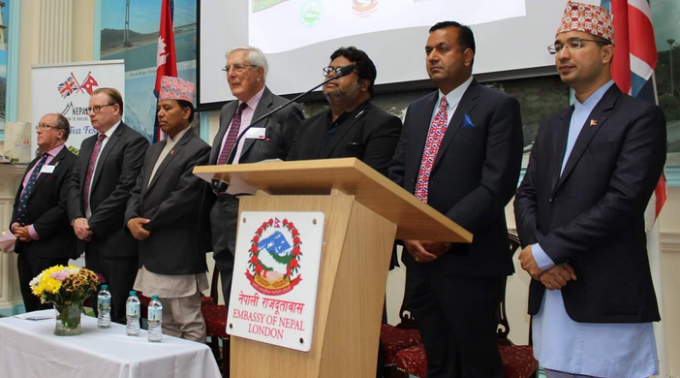
Some of the presenters during the playing of national anthems. Left to right: Mr Andrew Sparkes, former UK Ambassador to Nepal; Mr Marcus Jones MP; His Excellency Dr Durga Bahadur Subedi, Nepalese Ambassador to the UK; Mr David Thomas, Chairman of BRANNGO; Mr Rajendra Kumar Khetan, the Chairman of the Nepal-Britain Chamber of Commerce; Mr Kul Acharaya, Vice President for the UK of the Non-Resident Nepali Association; and Mr Sharad Raj Aran, Deputy Chief of Mission at the Embassy.

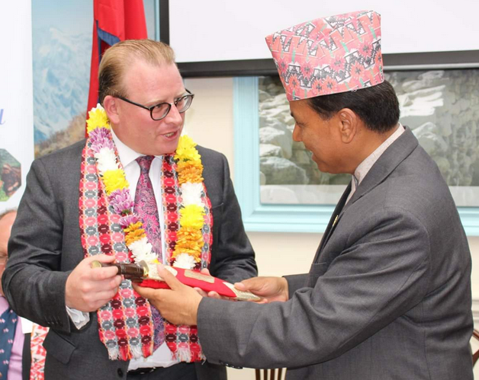
His Excellency Dr Durga Bahadur Subedi, the Nepalese Ambassador (right) presenting a kukri to Mr Marcus Jones MP.

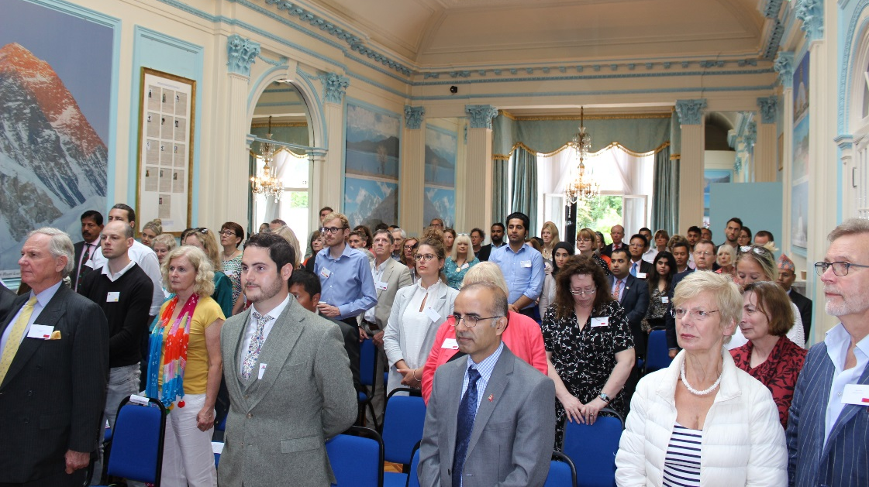
The audience!

